Data Sources and Currency
Each figure in this section is cited to its source; the table lists the data vintage and the date it was retrieved from the publishing agency.

Data Sources, Vintage and Retrieval Date
Dataset — source | Vintage | Retrieved
Locational amenities — Google Maps Platform (Places API, Static Maps) | Live listing at time of retrieval | October 3, 2026
Crime statistics — FBI Crime Data Explorer (Uniform Crime Reporting Program), agency level | 2025 data, CDE refresh 09/15/2026 | October 3, 2026
At-place employment by industry — BLS Quarterly Census of Employment and Wages | 2025 annual averages (change vs. 2020) | October 3, 2026
Total at-place employment and establishments — BLS QCEW | 2016–2025 annual averages | October 3, 2026
Long-term employment projections — Projections Central (U.S. DOL / state LMI) | 2024–2034 | October 3, 2026
Major employers — Hamilton County, TN Annual Comprehensive Financial Report, Statistical Section — Principal Employers, fiscal year 2025 | FY 2025
Unemployment and labor force — BLS Local Area Unemployment Statistics (LAUS) / Current Population Survey | 2015–2026 YTD annual; monthly through Aug 2026 | October 3, 2026
Commuting patterns — U.S. Census Bureau ACS 5-year (B08007, B08301, B08303, B08013) | 2024 5-year estimates | October 3, 2026
Wages by occupation — BLS Occupational Employment and Wage Statistics (OEWS) | May 2025 — Chattanooga, TN-GA Metropolitan Statistical Area | October 3, 2026
Building permits — U.S. Census Bureau, Building Permits Survey (place-level annual and year-to-date) | 2015–2026 YTD | October 3, 2026
Flood zone — FEMA National Flood Hazard Layer | Zone X (AREA OF MINIMAL FLOOD HAZARD) | October 3, 2026

Site & Neighborhood
The subject site is located at 1000 Market St, Chattanooga, TN 37402. Development location point: 35.04478, -85.30933 (decimal degrees, WGS84).
According to the FEMA National Flood Hazard Layer, the site is mapped in Flood Zone X (AREA OF MINIMAL FLOOD HAZARD), which is outside a Special Flood Hazard Area (retrieved October 3, 2026).

Area Services
The map and table below illustrate the location amenities in relation to the Subject site.
Not shown on this map (outside frame): #13–#15 — see table.
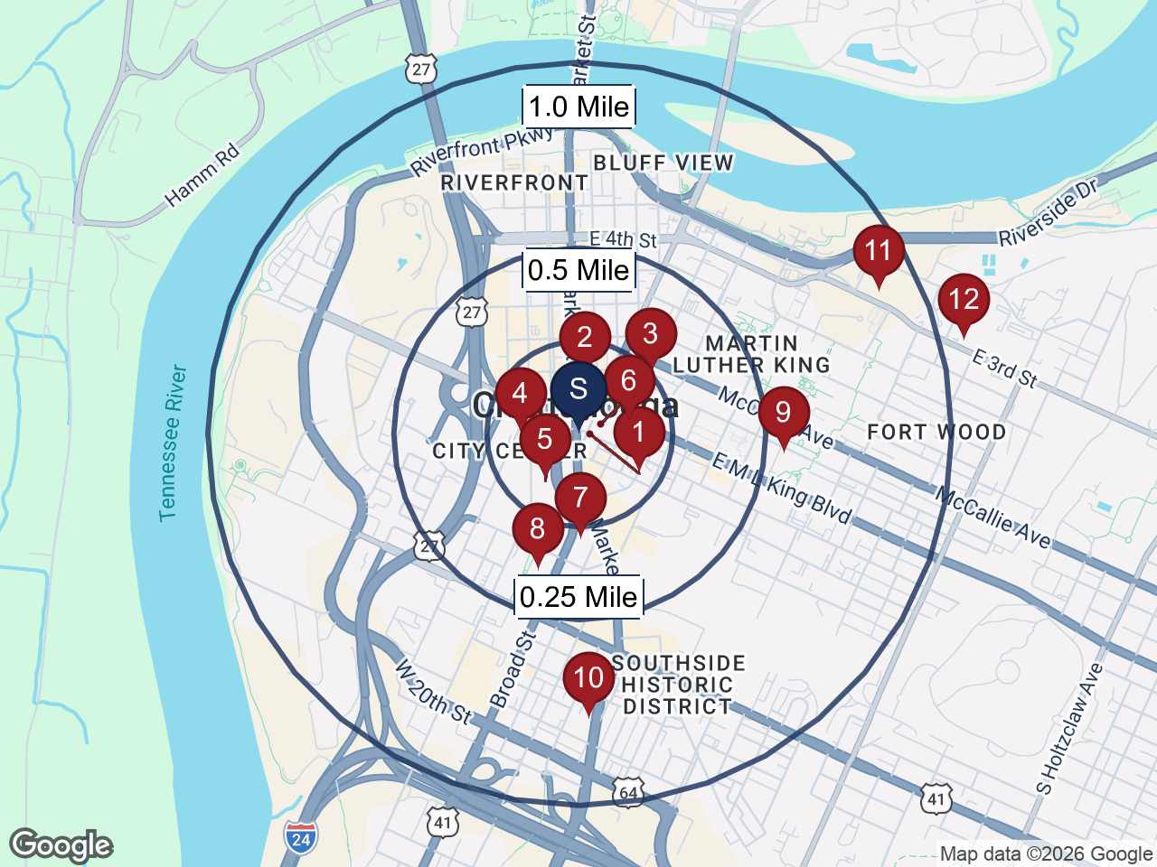
Distance From Local Services
Map # | Name | Service | Distance
1 | Bus Stop – 102 E 10th St | Transportation | 0.03 miles
2 | Miller Park | Recreation | 0.05 miles
3 | United States Postal Service | Post Office | 0.06 miles
4 | Downtown Branch - Chattanooga Public Library | Library | 0.08 miles
5 | Wilson Bank & Trust | Bank | 0.11 miles
6 | First Congregational Church | Church | 0.12 miles
7 | Concentra Urgent Care | Clinic | 0.30 miles
8 | Food City / Food City Pharmacy | Grocery / Pharmacy | 0.37 miles
9 | Tommie F. Brown Academy (Hamilton County; grades PK–5) | School (K-5) | 0.55 miles
10 | PURE | Gas Station | 0.77 miles
11 | Chattanooga School for the Arts and Sciences Upper (Hamilton County; grades 6–12) | School (6-8) | 0.89 miles
12 | Erlanger Hospital | Hospital | 1.06 miles
13 | The Howard School (Hamilton County; grades 9–12) | School (9-12) | 1.25 miles
14 | Charter Senior Living of Chattanooga | Private Senior Facility | 4.00 miles
15 | Rossville Senior Citizen Center | Senior Services | 4.63 miles

Crime Statistics
Below illustrates crime statistics for the Subject's area, as reported by FBI Crime Data Explorer (Uniform Crime Reporting Program), Chattanooga Police Department, calendar year 2025; rates per 100,000 (state and national on participating population), compared to the state and national crime statistics.
Total Crime Index  3998  per 100k people  113% higher than the US average | Victim Risk  1 in 25  113% higher than the US average | Year-over-Year Change  14%  Violent -15% · Property -14% (reported offenses, 2024→2025)  down

Crime Statistics — Chattanooga, TN
Statistic | Reported Incidents | Chattanooga  /100k | TN  /100k | National /100k
Total crime | 7,752 | 3998 | 2160 | 1881
Murder | 17 | 9 | 7 | 4
Rape | 139 | 72 | 37 | 37
Robbery | 141 | 73 | 42 | 50
Assault | 1,021 | 527 | 414 | 238
Violent crime | 1,318 | 680 | 499 | 329
Burglary | 692 | 357 | 207 | 195
Theft | 4,894 | 2524 | 1215 | 1147
Vehicle theft | 834 | 430 | 229 | 200
Property crime | 6,434 | 3319 | 1661 | 1552
After inspection and observation of the Subject’s neighborhood, we do not anticipate the overall crime statistics will affect the marketability for the Subject.

Major Employers
Major Employers — Chattanooga, TN — 2025
Employer | % of Total Employment (as published) | Employees | Rank
Erlanger Health System | 3.11% | 5,994 | 1
Hamilton County Schools | 3.00% | 5,781 | 2
Volkswagen Chattanooga | 2.72% | 5,239 | 3
Blue Cross Blue Shield of Tennessee | 2.15% | 4,145 | 4
Tennessee Valley Authority | 2.00% | 3,857 | 5
CHI Memorial Health Care System | 1.93% | 3,722 | 6
McKee Foods Corporation | 1.64% | 3,171 | 7
Unum Group | 1.60% | 3,082 | 8
Roper | 1.32% | 2,541 | 9
City of Chattanooga | 1.23% | 2,372 | 10
Source: Hamilton County, TN Annual Comprehensive Financial Report, Statistical Section — Principal Employers, fiscal year 2025 (view source)

At-Place Employment by Industry — Hamilton County, TN — 2025
Industry | Employment | % of Total | Avg. Annual Pay | Change 2020–2025
Education and Health Services | 48,302 | 22.0% | $68,010 | +57.1%
Trade, Transportation, and Utilities | 45,771 | 20.8% | $62,419 | -2.5%
Manufacturing | 28,170 | 12.8% | $79,019 | +18.7%
Professional and Business Services | 25,555 | 11.6% | $73,574 | +3.3%
Leisure and Hospitality | 24,947 | 11.4% | $27,471 | +25.1%
Financial Activities | 15,607 | 7.1% | $99,792 | -1.2%
Public Administration | 9,382 | 4.3% | $104,036 | +29.2%
Other Services | 6,794 | 3.1% | $53,378 | +15.0%
Construction * | 225 | 0.1% | $54,105 | -97.6%
Information * | 76 | 0.0% | $50,169 | -96.4%
Natural Resources and Mining * | 0 | 0.0% | — | —
Total, all industries | 219,580 | 100.0% | $69,253 | +10.3%
Source: U.S. Bureau of Labor Statistics, Quarterly Census of Employment and Wages (QCEW), 2025 annual averages (change vs. 2020). * One or more ownership components withheld by BLS for confidentiality; figure shown is a floor.

At-Place Employment — Hamilton County, TN — 2016 to 2025
Year | At-Place Employment | Establishments | Annual Change
2016 | 196,794 | 9,255 | —
2017 | 200,522 | 9,560 | +1.9%
2018 | 205,565 | 9,899 | +2.5%
2019 | 208,228 | 10,243 | +1.3%
2020 | 199,009 | 10,607 | -4.4%
2021 | 201,559 | 11,368 | +1.3%
2022 | 209,272 | 12,203 | +3.8%
2023 | 217,651 | 13,167 | +4.0%
2024 | 221,207 | 13,611 | +1.6%
2025 | 219,580 | 12,472 | -0.7%
Source: U.S. Bureau of Labor Statistics, Quarterly Census of Employment and Wages (QCEW), annual averages, all ownerships, all industries.

Long-Term Employment Projections — Tennessee — 2024 to 2034
Major Occupational Group | 2024 | 2034 | Change | Avg. Annual Openings
Office and Administrative Support | 472,350 | 480,630 | +1.8% | 52,570
Transportation and Material Moving | 393,760 | 428,140 | +8.7% | 52,480
Food Preparation and Serving Related | 302,180 | 337,640 | +11.7% | 62,370
Sales and Related | 281,260 | 287,900 | +2.4% | 37,450
Management | 276,710 | 309,900 | +12.0% | 25,480
Production | 268,130 | 277,480 | +3.5% | 30,250
Healthcare Practitioners and Technical | 226,980 | 250,090 | +10.2% | 15,120
Business and Financial Operations | 191,830 | 212,050 | +10.5% | 17,180
Educational Instruction and Library | 160,340 | 175,280 | +9.3% | 15,770
Installation, Maintenance, and Repair | 155,520 | 173,230 | +11.4% | 15,980
Construction and Extraction | 153,390 | 176,670 | +15.2% | 15,340
Healthcare Support | 106,260 | 121,940 | +14.8% | 17,240
Building and Grounds Cleaning and Maintenance | 106,190 | 116,810 | +10.0% | 16,010
Personal Care and Service | 79,920 | 87,490 | +9.5% | 14,850
Computer and Mathematical | 79,590 | 89,890 | +12.9% | 5,490
Protective Service | 72,870 | 79,840 | +9.6% | 8,850
Community and Social Service | 65,220 | 72,170 | +10.7% | 6,670
Arts, Design, Entertainment, Sports, and Media | 55,400 | 60,070 | +8.4% | 5,930
Architecture and Engineering | 45,710 | 50,050 | +9.5% | 3,650
Farming, Fishing, and Forestry | 24,670 | 24,120 | -2.2% | 3,510
Life, Physical, and Social Science | 24,540 | 26,670 | +8.7% | 2,220
Legal | 19,360 | 20,560 | +6.2% | 1,290
Total, all occupations | 3,577,180 | 3,874,620 | +8.3% | 427,410
Source: Projections Central (Projections Managing Partnership, sponsored by the U.S. Department of Labor), Tennessee long-term occupational projections 2024–2034; major groups are sums of the published detailed occupations.

WARN Notices — Hamilton County, TN
Employer | Location | Notice Date | Employees Affected | Type
Pilgrim's Pride Corporation | Hamilton County | 2026-06-16 | 315
Shimmick Construction Company, Inc. | Hamilton County | 2026-05-26 | 183
Yanfeng International Automotive Technology US I LLC | Hamilton County | 2026-04-29 | 153
T-Mobile USA, Inc. | Hamilton County | 2026-04-16 | 200
All Heart Pediatric Cardiology | Hamilton County | 2026-03-05 | 1
Source: State WARN notices (Tennessee DLWD — WARN and closure/layoff reports), https://www.tn.gov/workforce/general-resources/major-publications0/major-publications-redirect/reports.html; analyst-verified; notice links on file
At-place employment in Hamilton County totaled 219,580 in 2025, an increase of 11.6 percent since 2016 (peak of 221,207 in 2024). The largest sectors are education and health services (22.0 percent), trade, transportation, and utilities (20.8 percent), manufacturing (12.8 percent). The Chattanooga, TN unemployment rate was 3.8 percent in Aug 2026, compared with 3.7 percent for TN and 4.3 percent nationally. Tennessee projects total employment to grow 8.3 percent from 2024 to 2034 (3,577,180 to 3,874,620), with 427,410 average annual openings.

Workforce and Unemployment Trends
The table below illustrates the workforce and unemployment trends for the city of Chattanooga and Hamilton County.
Unemployment Trends - 2015 - 2026 YTD
 | Chattanooga, TN |  |  |  | Hamilton County, TN
Year | Total Labor  Force | Total  Employment | Unemployment  Rate (%) | Rate  Change | Total Labor  Force | Total  Employment | Unemployment  Rate (%) | Rate  Change
2015 | 80,096 | 75,477 | 5.8 | - | 167,930 | 159,129 | 5.2 | -
2016 | 85,409 | 81,360 | 4.7 | (1.1) | 173,024 | 165,171 | 4.5 | (0.7)
2017 | 87,523 | 84,246 | 3.7 | (1.0) | 177,253 | 170,860 | 3.6 | (0.9)
2018 | 90,088 | 86,957 | 3.5 | (0.2) | 181,617 | 175,599 | 3.3 | (0.3)
2019 | 91,884 | 88,832 | 3.3 | (0.2) | 186,035 | 180,200 | 3.1 | (0.2)
2020 | 91,606 | 84,205 | 8.1 | 4.8 | 183,629 | 170,749 | 7.0 | 3.9
2021 | 90,839 | 86,366 | 4.9 | (3.2) | 184,068 | 176,355 | 4.2 | (2.8)
2022 | 92,576 | 89,259 | 3.6 | (1.3) | 188,391 | 182,161 | 3.3 | (0.9)
2023 | 95,827 | 92,653 | 3.3 | (0.3) | 194,621 | 188,699 | 3.0 | (0.3)
2024 | 98,776 | 95,512 | 3.3 | 0.0 | 199,759 | 193,549 | 3.1 | 0.1
2025 | 100,540 | 96,934 | 3.6 | 0.3 | 203,165 | 196,430 | 3.3 | 0.2
2026 YTD | 99,085 | 95,482 | 3.6 | 0.0 | 200,147 | 193,489 | 3.3 | 0.0
Source: Bureau of Labor Statistics
Between 2015 and 2019, Chattanooga's unemployment rate declined each year, falling from 5.8 percent in 2015 to a period low of 3.3 percent in 2019, before climbing to 8.1 percent in 2020 due to the impact of the COVID-19 pandemic. The following two years saw consistent improvement, with the unemployment rate falling to 3.6 percent by 2022. By 2023 and 2024, the rate had edged down further to 3.3 percent before rising modestly to 3.6 percent in 2025. Hamilton County has followed a similar trend.
Below we have compared the city, county, MSA, state, and national unemployment rates over the past 24 months. Data was not available for Oct 2025. Sep 2026 had not yet been published for all local areas at the time of report generation.
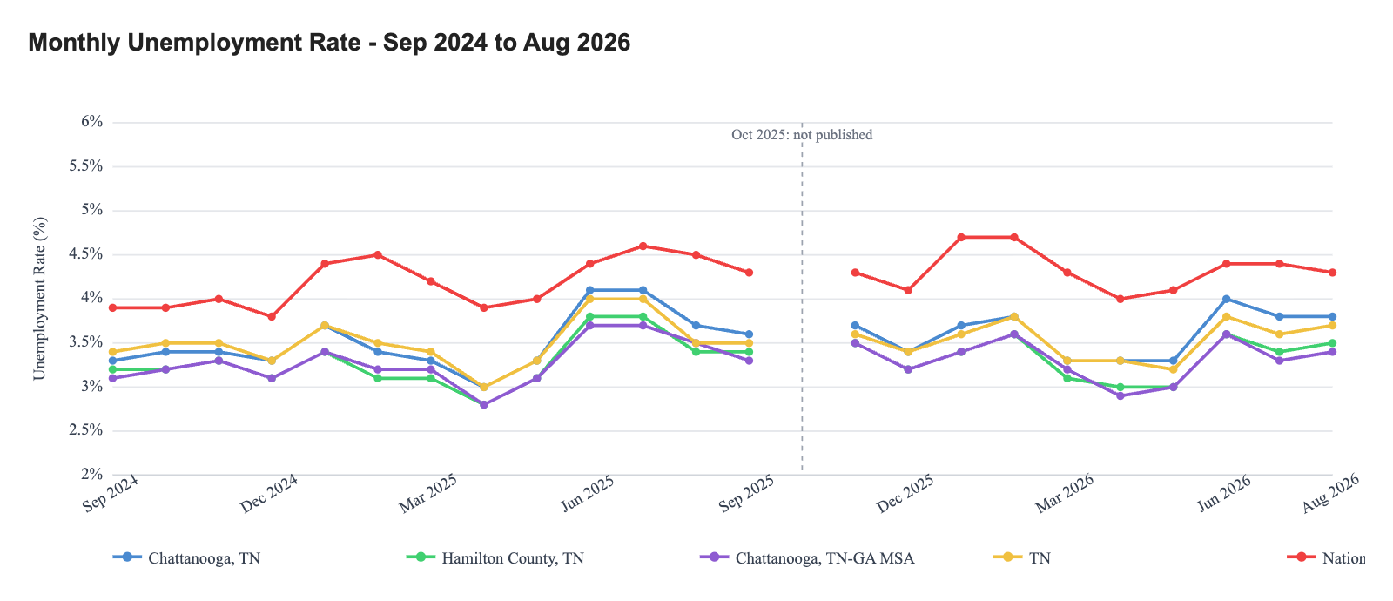

Over the past 24 months, Chattanooga's unemployment rate has generally tracked above Hamilton County and the Chattanooga MSA, while remaining close to or in line with the state rate. Both the city and the county have consistently reported unemployment rates below the national level throughout the period. The state has generally mirrored the city's rate, with both falling below the national average across most of the comparison period. Hamilton County and the MSA have tended to occupy the lowest positions among the local and state series, while the national rate has remained the highest benchmark throughout.

Employment Trends
Employment Trends - 2015 - 2026 YTD
 | Chattanooga, TN |  | Hamilton County, TN |  | Chattanooga, TN-GA MSA
Year | Total Employment | % Change | Total Employment | % Change | Total Employment | % Change
2015 | 75,477 | — | 159,129 | — | 239,574 | —
2016 | 81,360 | 7.8% | 165,171 | 3.8% | 246,072 | 2.7%
2017 | 84,246 | 3.5% | 170,860 | 3.4% | 255,138 | 3.7%
2018 | 86,957 | 3.2% | 175,599 | 2.8% | 261,103 | 2.3%
2019 | 88,832 | 2.2% | 180,200 | 2.6% | 266,248 | 2.0%
2020 | 84,205 | (5.2%) | 170,749 | (5.2%) | 253,039 | (5.0%)
2021 | 86,366 | 2.6% | 176,355 | 3.3% | 261,834 | 3.5%
2022 | 89,259 | 3.3% | 182,161 | 3.3% | 269,385 | 2.9%
2023 | 92,653 | 3.8% | 188,699 | 3.6% | 279,201 | 3.6%
2024 | 95,512 | 3.1% | 193,549 | 2.6% | 284,941 | 2.1%
2025 | 96,934 | 1.5% | 196,430 | 1.5% | 287,683 | 1.0%
2026 YTD | 95,482 | (1.5%) | 193,489 | (1.5%) | — | —
Source: U.S. Bureau of Labor Statistics, Local Area Unemployment Statistics (LAUS)

Commuting Patterns

Place of Work — Hamilton County, TN (183,372 workers)
Destination | Workers | Share
Worked in county of residence | 169,084 | 92.2%
Worked outside county of residence (same state) | 7,094 | 3.9%
Worked outside state of residence | 7,194 | 3.9%

Means of Transportation to Work — Hamilton County, TN
Means | Workers | Share
Drove alone | 136,033 | 74.2%
Carpooled | 15,363 | 8.4%
Public transportation | 1,038 | 0.6%
Walked | 2,931 | 1.6%
Bicycle | 363 | 0.2%
Taxicab, motorcycle, or other | 1,377 | 0.8%
Worked from home | 26,267 | 14.3%

Travel Time to Work — Hamilton County, TN (mean 22.1 minutes)
Travel time | Workers | Share
Less than 5 minutes | 3,790 | 2.4%
5 to 9 minutes | 14,622 | 9.3%
10 to 14 minutes | 22,681 | 14.4%
15 to 19 minutes | 32,036 | 20.4%
20 to 24 minutes | 28,515 | 18.2%
25 to 29 minutes | 12,996 | 8.3%
30 to 34 minutes | 22,648 | 14.4%
35 to 39 minutes | 4,711 | 3.0%
40 to 44 minutes | 3,894 | 2.5%
45 to 59 minutes | 6,522 | 4.2%
60 to 89 minutes | 2,401 | 1.5%
90 or more minutes | 2,289 | 1.5%
Source: U.S. Census Bureau, American Community Survey 5-Year Estimates (2024), Tables B08007, B08301, B08303, B08013.

Wages by Occupation
The chart below shows the wages by occupation for the Chattanooga, TN-GA MSA.
Wage by Occupation — Chattanooga, TN-GA MSA
Occupational Title | # Employees | Avg Hourly Wage | Avg Annual Wage
All Occupations | 268,750 | $28.21 | $58,680
Management Occupations | 16,250 | $61.95 | $128,860
Legal Occupations | 1,460 | $56.62 | $117,770
Architecture and Engineering Occupations | 4,960 | $46.61 | $96,960
Healthcare Practitioners and Technical Occupations | 19,140 | $45.79 | $95,230
Computer and Mathematical Occupations | 5,490 | $43.74 | $90,970
Business and Financial Operations Occupations | 14,590 | $39.54 | $82,230
Life, Physical, and Social Science Occupations | 1,090 | $38.96 | $81,030
Arts, Design, Entertainment, Sports, and Media Occupations | 2,780 | $29.32 | $60,990
Educational Instruction and Library Occupations | 11,620 | $28.00 | $58,250
Installation, Maintenance, and Repair Occupations | 12,760 | $27.58 | $57,370
Construction and Extraction Occupations | 10,130 | $27.43 | $57,040
Community and Social Service Occupations | 4,030 | $26.61 | $55,340
Protective Service Occupations | 5,000 | $24.85 | $51,680
Production Occupations | 26,250 | $23.45 | $48,770
Office and Administrative Support Occupations | 33,970 | $22.68 | $47,170
Sales and Related Occupations | 22,440 | $22.01 | $45,770
Transportation and Material Moving Occupations | 28,050 | $20.87 | $43,410
Healthcare Support Occupations | 9,790 | $19.08 | $39,690
Farming, Fishing, and Forestry Occupations | 270 | $18.97 | $39,450
Building and Grounds Cleaning and Maintenance Occupations | 8,020 | $17.04 | $35,430
Personal Care and Service Occupations | 4,770 | $16.50 | $34,310
Food Preparation and Serving Related Occupations | 25,880 | $14.86 | $30,900
Source: Bureau of Labor Statistics, Occupational Employment and Wage Statistics (OES)

The above chart shows average hourly and annual wages by employment classification. The classification with the lowest average hourly wage was food preparation and serving related occupations, at $14.86 per hour. The highest average hourly wage of $61.95 was for management occupations.

Building Permits
The following table demonstrates building permit information from 2015 through 2026 YTD in Chattanooga.
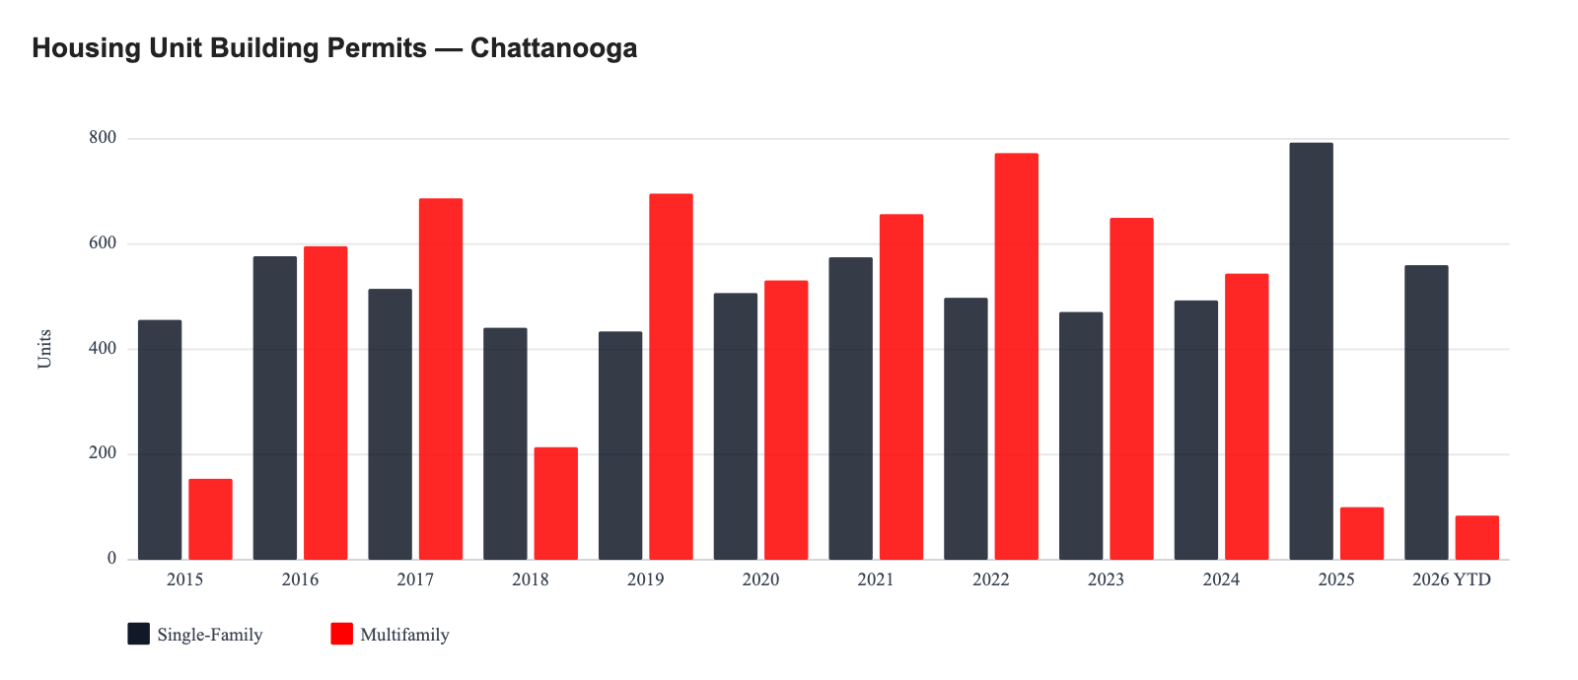

Between 2015 and 2025, single-family permits in Chattanooga peaked at 793 units in 2025 and were lowest at 434 units in 2019. Multifamily permits peaked at 773 units in 2022; 8 of the 11 years (2016 through 2017 and 2019 through 2024) exceeded the period average of 509 multifamily units per year. 2026 YTD through August 2026 shows 560 single-family and 84 multifamily units.

Sources
Flood Zone: FEMA National Flood Hazard Layer (NFHL), Flood Hazard Zones layer, queried at the subject coordinates — verify
Public Schools: National Center for Education Statistics, Common Core of Data (CCD) School Characteristics 2024-2025, via the NCES EDGE program — public, open, non-charter schools; district and grade span as published — verify
Locational Amenities: Google Maps Platform (Places API and Static Maps); distances are straight-line miles from the Subject
Crime Data: FBI Crime Data Explorer (Uniform Crime Reporting Program), Chattanooga Police Department, calendar year 2025; rates per 100,000 (state and national on participating population) — verify
Major Employers: Hamilton County, TN Annual Comprehensive Financial Report, Statistical Section — Principal Employers, fiscal year 2025 (https://www.hamiltontn.gov/PDF/CAFR/2025/FY%202025%20ACFR.pdf)
Employment by Industry and At-Place Employment: U.S. Bureau of Labor Statistics, Quarterly Census of Employment and Wages (QCEW) — verify
Employment Projections: Projections Central (Projections Managing Partnership, sponsored by the U.S. Department of Labor), Tennessee long-term occupational projections 2024–2034 — verify
Unemployment and Employment Trends: U.S. Bureau of Labor Statistics, Local Area Unemployment Statistics (LAUS); national rate from the Current Population Survey (not seasonally adjusted) — verify
Commuting Patterns: U.S. Census Bureau, American Community Survey 5-Year Estimates (2024), Tables B08007, B08301, B08303, B08013 — verify
Wages: U.S. Bureau of Labor Statistics, Occupational Employment and Wage Statistics (OEWS) — verify
Building Permits: U.S. Census Bureau, Building Permits Survey (place-level annual and year-to-date) — verify

Data Verification Appendix
Each dataset in this report is listed with the exact identifiers it was retrieved by and a link to the publisher's query, so a reviewer can reproduce every figure without relying on this document. Retrieval dates are stamped when the data was pulled.

Dataset | Identifiers used | Direct link | Retrieved
Flood zone — FEMA National Flood Hazard Layer, Flood Hazard Zones (layer 28) | Point 35.04478, -85.30933 (WGS84) | Open source query | October 3, 2026
Public schools — NCES Common Core of Data, School Characteristics (via NCES EDGE) | Tommie F. Brown Academy (Hamilton County; grades PK–5): NCESSCH 470159001791; Chattanooga School for the Arts and Sciences Upper (Hamilton County; grades 6–12): NCESSCH 470159000669; The Howard School (Hamilton County; grades 9–12): NCESSCH 470159000759 | NCES school detail (470159001791) | October 3, 2026
Locational amenities and drive times — Google Maps Platform (Places API, Static Maps, Routes API) | Live listings at time of retrieval; Google does not publish a stable public query URL | No independent link — see retrieval date | October 3, 2026
Crime — FBI Crime Data Explorer, summarized agency counts (Chattanooga Police Department) | ORI TN0330100; offenses HOM, RPE, ROB, ASS, V, BUR, LAR, MVT, P; calendar year 2025 | CDE API (requires a free api.data.gov key) | October 3, 2026
At-place employment by industry — BLS QCEW annual averages (county) | Area FIPS 47065; year 2025 vs 2020 | QCEW CSV | October 3, 2026
At-place employment and establishments — BLS QCEW timeseries | Series ENU4706510010, ENU4706520010 | BLS series | October 3, 2026
Long-term occupational projections — Projections Central (state LMI, U.S. DOL) | State FIPS 47; 2024–2034 | Projections Central JSON | October 3, 2026
Major employers — Hamilton County, TN Annual Comprehensive Financial Report, Statistical Section — Principal Employers, fiscal year 2025 | 10 employers as listed in the source | Source document | October 3, 2026
WARN notices — state rapid-response listing | Pilgrim's Pride Corporation; Shimmick Construction Company, Inc.; Yanfeng International Automotive Technology US I LLC; T-Mobile USA, Inc.; All Heart Pediatric Cardiology | State WARN listing | —
Unemployment and labor force (annual) — BLS Local Area Unemployment Statistics | Chattanooga, TN: LAUCT471400000000006, LAUCT471400000000005, LAUCT471400000000003; Hamilton County, TN: LAUCN470650000000006, LAUCN470650000000005, LAUCN470650000000003; Chattanooga, TN-GA MSA: LAUMT471686000000006, LAUMT471686000000005, LAUMT471686000000003; TN: LAUST470000000000006, LAUST470000000000005, LAUST470000000000003 | BLS series LAUCT471400000000006 | October 3, 2026
Unemployment rate (monthly) — BLS LAUS; national from Current Population Survey (LNU04000000, NSA) | Chattanooga, TN: LAUCT471400000000003; Hamilton County, TN: LAUCN470650000000003; Chattanooga, TN-GA MSA: LAUMT471686000000003; TN: LAUST470000000000003; National: LNU04000000 | BLS series LAUCT471400000000003 | October 3, 2026
Commuting patterns — U.S. Census Bureau ACS 5-year (2024) | County GEOID 47065; tables B08007, B08301, B08303, B08013 | Census API query | October 3, 2026
Wages by occupation — BLS OEWS May 2025 | Chattanooga, TN-GA Metropolitan Statistical Area. Identifiers not recorded — re-run Auto-Fill for this section to record them | BLS OEWS | October 3, 2026
Building permits — U.S. Census Bureau Building Permits Survey, annual place files | Place GEOID 4714000 | BPS place files directory | October 3, 2026

Submission Checklist — Tennessee Housing Development Agency
Items this agency's market-study guideline requires of the sections above, with whether each is present in this document. Source: THDA Market Study Guidance (Last Updated January 30, 2026): NCHMA Model Content Standards + THDA additions, organized in the NCHMA Market Study Index format (https://dogvxws799i6n.cloudfront.net/wp-content/uploads/MF_2026_-Market-Study-Guidance_ADA-1.29.2026.pdf). The checklist is for the analyst's review and is not a determination of compliance.

Required items and status
Required item | Where required | In this document
Development Location Point in decimal-degree latitude/longitude | THDA Guidance — Scope | Yes
PMA census tracts listed by FIPS (report + CSV) and shapefiles | THDA Guidance — PMA | No — add before submission
Nearest grocery, convenience store, pharmacy, hospital or walk-in clinic, bank, retail shopping | THDA — Area Services | Yes
Transit system, nearest stop, distance and routes | THDA — Area Services (Transportation) | Yes
Public K-12 schools: name, location, grades, district, distance (non-senior) | THDA — Area Services | Yes
Study less than six months old at submission | THDA Guidance; QAP §3.B.1 | Yes
Employment & economy per NCHMA §F (at-place, sectors, unemployment, employers, wages, commuting) | THDA adopts NCHMA | Yes
Building permits by housing type | NCHMA §G.5 | Yes

